Zork

Team10

Jeanne Deng

Huyue Gu

Jiali Du

Chengcheng Xu

Neng Gu

1. Problem Statement

Zork was text adventure games from the early 1980s . Known as one of the first text based interactive role-playing adventure computer games, we are going to design an advanced version for more fun and interactive among players.

2. Background Information

Zork was born 1979, as one of the earliest [interactive fiction](http://en.wikipedia.org/wiki/Interactive_fiction) [computer games](http://en.wikipedia.org/wiki/Computer_game), with roots drawn from the original genre game. We are converting it form terminal to visual product. Now a exciting game requires multiple player mode, we will build this game based on original functionality of Zork and also implement a client-server mode, which allows user to play the game anywhere on any computer. We will create a vivid UI, which provides login and other additional functions. For testing purpose, we will give our S3 bucket to the testing team and we will write a user manual to clarify the instructions.

3. Environment and System Models

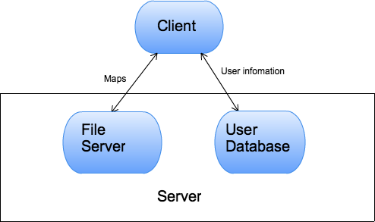

4. Functional Requirements

**1. Interactions between User and Client**

a. User can create/log in account

b. User can do all gameplay command

c. User can save in-game process on User Server

i. User can move east/west/north/south

ii. User can use inventory

iii. User can take/drop/put/turn on item

iv. User can open container

v. User can read item

vi. User can attack creature with item

vii. User can exit

d. User can retrieve saved in-game process from User Server

e. User can create their own game map and save it on Map Server

f. User can retrieve their created game map from Map Server

**2. Interactions between Client and User Server**

a. Client can request create/log in command to User Server

b. Client can request new save data command to User Server

c. Client can request retrieve saved data command to User Server

**3. Interactions between Client and Map Server**

a. Client can request new save file command to Map Server

b. Client can request retrieve saved file command to Map Server

5. Non-Functional Requirements

**1. Performance requirements**

The map should load in less than 2 seconds, as well as saving the game.

Upload map should be under 10 seconds according to the size of the map.

**2. Platform**

Amazon EC2 server should be able to handle amounts of requests from different clients at the same time. Front end application should be lightweight and not consume a lot of resources

**3. Reliability**

Since our project is running on Amazon cloud server, server reliability is robust.

**4. Usability**

The server should be very easy to use. The user will send and receive map data from the file server. The server will store user informations on database.

6. Use Cases

**Case: A new user wants to play the game:**

1) In the login window, the user types in the username and password of his choice.

2) After the registration, he will be about to view the list of maps on the server.

3) The user will then be able to choose a map and download it.

4) He can now play Zork.

**Case: A user wants to save the current state:**

1) A user is playing Zork and want to save the current state for later playing.

2) The user will click the ‘save’ button.

3) The user will be able to view all his saved data.

4) The user can choose an empty slot or override an old saved data.

5) A success message will show up if the save successes.

**Case: A return user wants to continue his game:**

1) In the login window, the user types in the username and password.

2) The user will be able to choose either to start a new game or continue an old saved state.

3) If the user choose to continue on an old record, a list of all his saved records will be shown.

4) The user will then be able to choose the one he/she wants to continue playing.

**Case: A user wants to upload a new map**

1) The user will select the ‘upload map’ opinion in the menu bar.

2) A file chooser will pop up and the user will then be able to choose the file he wants to upload.

3) After the validation and upload, the user will be able to see a success message says the file is successfully uploaded.

4) The user will then be able to see the map in the map list.